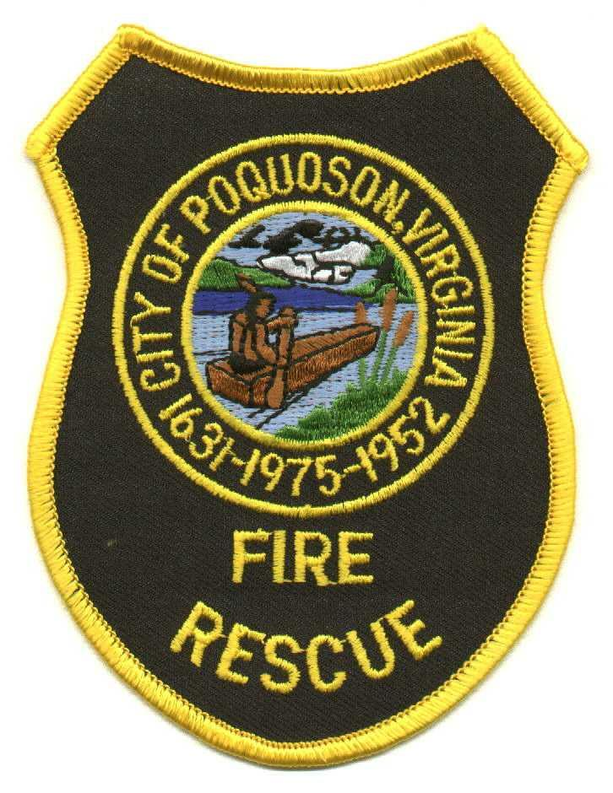

City of Poquoson Fire/Rescue
830 Poquoson Avenue, Poquoson, Virginia 23662 (757) 868-3510 Fax (757) 868-3514

Summary

- Update to GA 4.00 – Tobacco Product Use.

- Updated name of policy to include smoking and vaping.

- Added the term “vaping” throughout policy wherever “tobacco product” was used.

- Replaced “no smoking pledge” with “Employment Agreement”.

- Added a bullet point defining both Vaping and E-Cigarette.

- Made minor grammatical and formatting edits (page numbers, spacing, etc.)

